

**Unit #1: Functions**

**Section #1: Vocabulary (words and/or diagrams)**

**Define each:**

|  |  |  |
| --- | --- | --- |
| **Relation-**  **Function-**  **Parent function-**  **Domain-**  **Range-**  **One to one function-** | **Vertical line test-**  **Horizontal line test-**  **X-intercept-**  **Y-intercept-**  **Inverse function-**  **Inverse function notation-** | **Relative maximum/ minimum-**    **Absolute maximum/ minimum-**  **Increasing/Decreasing function**  **Where function positive-**  **Where function negative-** |

**Section #2: Formulas/Equations/Rules**

* [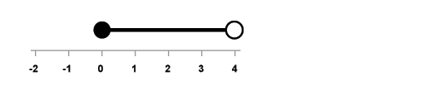](http://www.google.com/url?sa=i&rct=j&q=&esrc=s&source=images&cd=&cad=rja&uact=8&ved=0CAcQjRxqFQoTCI_y07iE28cCFccXPgodPv8ICg&url=http%3A%2F%2Fwww.bbc.co.uk%2Fbitesize%2Fks3%2Fmaths%2Falgebra%2Finequalities_simultaneous%2Frevision%2F3%2F&psig=AFQjCNGGd8cjmhtEagGfG1wYOsWY8WAYdA&ust=1441375511150068)**Set notation: Express each in both set builder notation AND interval notation.**

****A) B)

* **Composition rule: If f(x)= x2 – 1 and g(x) = 3x + 2, evaluate each:**



**C) f(g(x)) express as a trinomial D) (gf)(x) express as a binomial**

* **Restricted domains: Determine the restricted domain for each function by showing your process!!**

1. **f(x) = $\frac{4x^{2}}{x-7}$ F) g(x) =** **G) h(x) =**

**Section #3: Key methods and concepts (show a solved example for each)**

* **The inverse of a function is also a function if the original function is__________________.**
* **A) Show how to find the inverse of f(x) =  graphically and algebraically.**

**Algebraically Graphically**

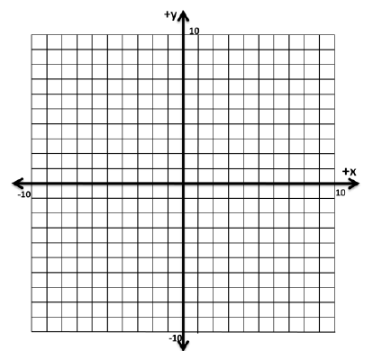

**Reflect over the line y = ___________**

* **3 ways to prove an inverse- Show that f(x) = in the domain $x≥0$ and g(x)=  in the domain $x≥3$ are inverses.  
  Graphically, Algebraically and Using compositions**

** Algebraically Graphically**

**Compositions**

**Answers: 2A) $\{0≤x<4\}$ $[0,4)$ B) $\{x≤-3 or x>4\}$ $(-∞,-3]∪(4,∞)$ C) $9x^{2}+12x+3$**

**D) $3x^{2}-1$ E) $x≠7$ F) $x≥8$ G) $x>-4$ 3A) $f^{-1}\left(x\right)=\frac{7}{3}x+\frac{70}{3}$**

* **Parent functions: Graph all the given** parent functions on the next page!!!

|  |  |
| --- | --- |
| 1. **Linear Function**  or     Domain:  Range: | 1. **Absolute Value Function**  or     Domain:  Range: |
| 1. **Quadratic Function**  or     Domain:  Range: | 1. **Square Root Function**  or       Domain:  Range: |
| 1. **Exponential Function**  or     Domain:  Range: | 1. **Logarithmic Function**  or   Domain:  Range: |
| 1. **Rational Function (Reciprocal Function)**   or      Domain:  Range: | 1. **Cubic Function**  or     Domain:  Range: |